Project # 3

This assignment will cover several chapters(5,6,7,8)
For this assignment, you have the following task
- Create a new folder for the JavaJam
- Create a new music page (music.html)
- Modify the HomePage to implement the two column page layout
- Modify the javajam.css to configure the two column page layout
- Modify the menu to use a table
- Save your folder as yourname_assignment3
- Include in your folder all the pages of the project. Compress and submit.

Submitting only screenshots of the project will give a grade of 0.

Colors: #221811( for the text), #FCEBB6( for the background), #D2B48C ( for the text background)
Font: Verdana, Arial or any sans-serif font.
Style for the h1: 200% line height
Style for the nave element selector that configures centered, bold text
Styles for the footer element selector that configure background color, small font size ( .60 em) italics and centerd text.
Configure home.html and menu.html content that is centered 80% width (use a style rule with id named wrapper)

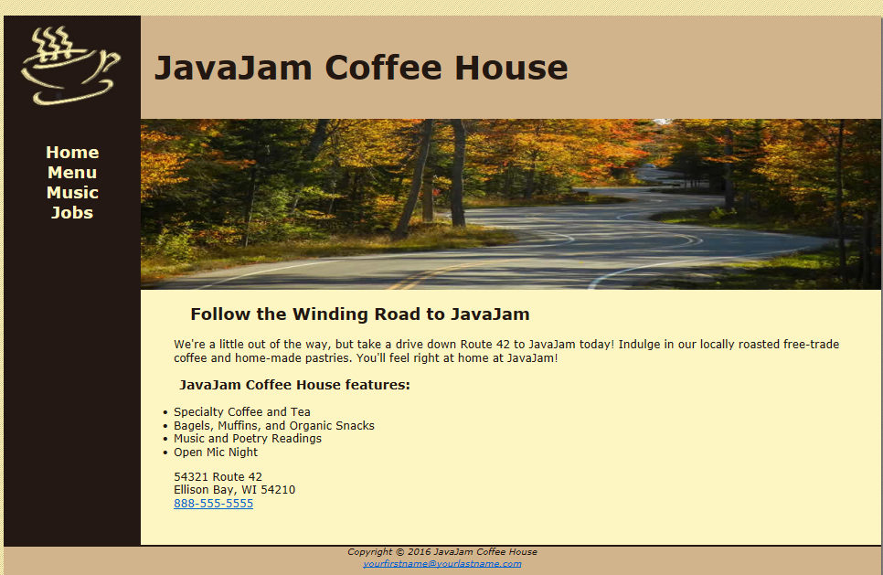
Home.html
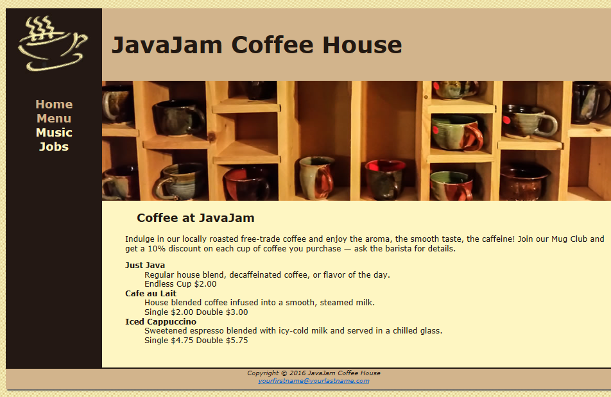
Menu.html
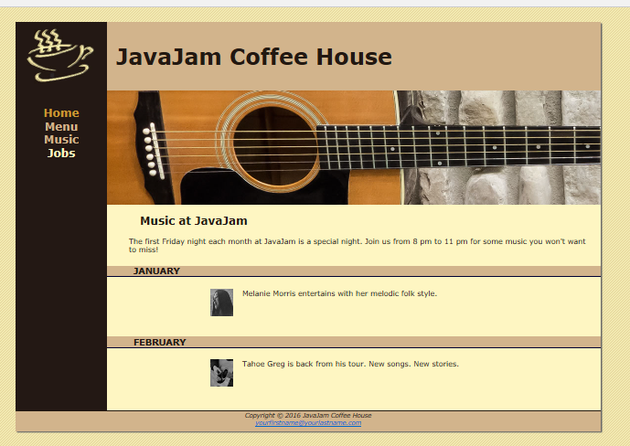
Music.html ( Uses static data)

